Due **Apr 5, 2023**

**1000-1500 Words**

Note: Clear responses show understanding and heavily edit for grammar and logic. Substance is second **Quality** is what is being looked for.

A range.

Essay has a clear structure, with an excellent introduction and conclusion. Paragraphing is excellent and there are clear directions - indicators (sign - posting). The content is relevant to the question set and is covered at the required level of depth . There is exceptional understanding of the topic. There is a logically developed argument which shows critical analysis , independence of thought , and originality . Expression is economical, clear and concise . Presentation is very good, with correct spelling and punctuation throughout. Good use is made of the relevant literature. Quotations are relevant, apt, and properly reference

Question:

Why did Kant argue that only acts performed out of a sense of duty are acts that have moral worth? Explain Kant’s conception of the role of duty in morality, using one or two examples to illustrate. Do you agree with Kant about the significance of motives and the role of duty in morality? Why/why not?

Given resource:

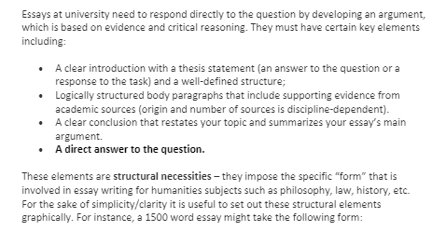

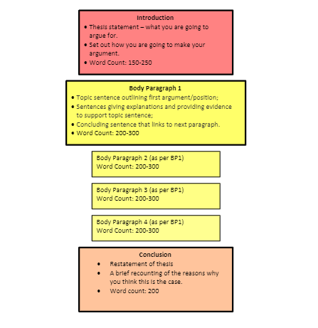

I. Introduction

A. Explanation of Kant's argument that only acts performed out of a sense of duty have moral worth

B. Overview of Kant's conception of the role of duty in morality

C. Thesis statement outlining the position the essay will take on Kant's argument

II. Kant's Conception of Duty in Morality

A. Kant's definition of duty and its relationship to morality

B. The role of the categorical imperative in Kant's ethical theory

C. Kant's distinction between hypothetical and categorical imperatives

D. The significance of motives in Kant's ethical theory

III. Examples of Kant's Conception of Duty in Morality

A. The case of the shopkeeper who gives the correct change

B. The case of the soldier who risks their life to save a fellow soldier

C. Explanation of how these cases illustrate Kant's conception of duty in morality

IV. Criticisms of Kant's Conception of Duty in Morality

A. Objections to Kant's focus on motive

B. Objections to Kant's reliance on duty as the basis of moral worth

C. Alternative ethical theories that challenge Kant's conception of duty in morality

V. The Significance of Motives and the Role of Duty in Morality

A. Explanation of why the significance of motives is important in moral decision-making

B. Analysis of whether Kant's focus on duty is the most important aspect of moral decision-making

C. Discussion of the importance of balancing duty and personal inclination in moral decision-making

VI. Conclusion

A. Summary of the main points of the essay

B. Reiteration of the thesis statement

C. Final thoughts on the significance of motives and the role of duty in morality.